**Assignment 1**

**TASK 1 : Set Up Your Unity Project & Configure the VR Environment**

To set up our Unity project for VR, start by installing Unity Hub and the latest LTS version of the Unity Editor which supports VR development. Then, create a new project using the "3D" template. Set Up your project settings under "Edit > Project Settings," and adjust the player settings ,then Import the necessary VR packages into the Package Manager, set up your VR environment by adding components like the VR Camera, and locate your scene for VR interaction.

**Task 2: Create the Ground Plane**

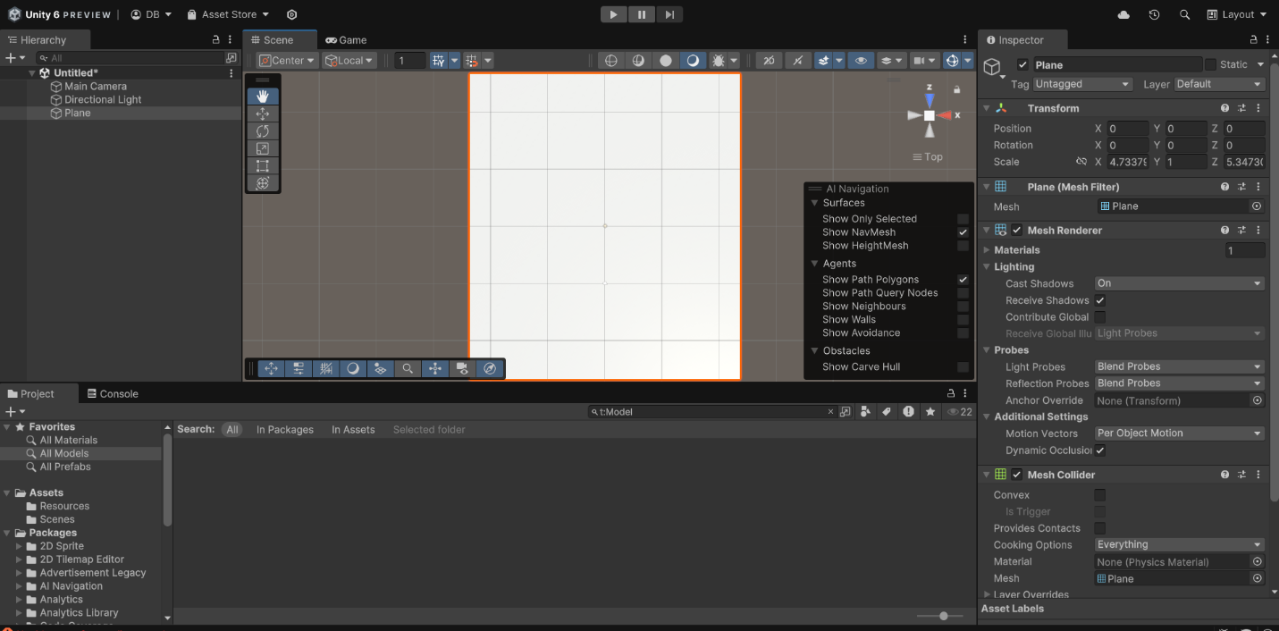

**Task 3: Add a skybox**

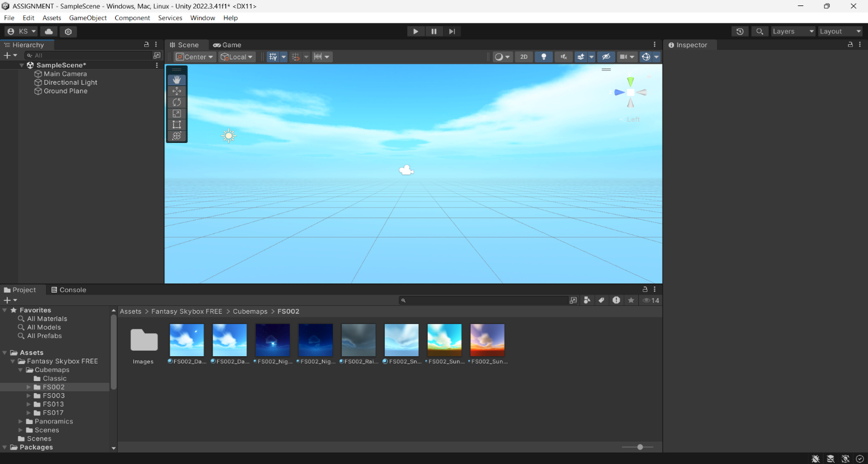

**Task 4: Add Environment Objects**